**DLD LAB_05[B]**

**TASK 3: Create a 2-bit subtracter circuit and implement it on breadboard along with truth table.**

**TRUTH TABLE:**

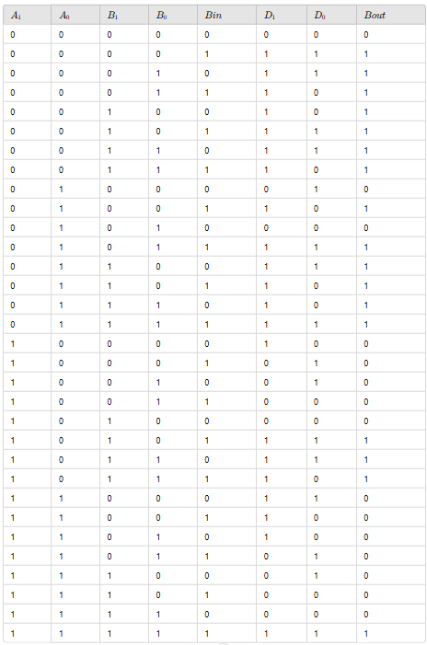

**CIRCUIT:**

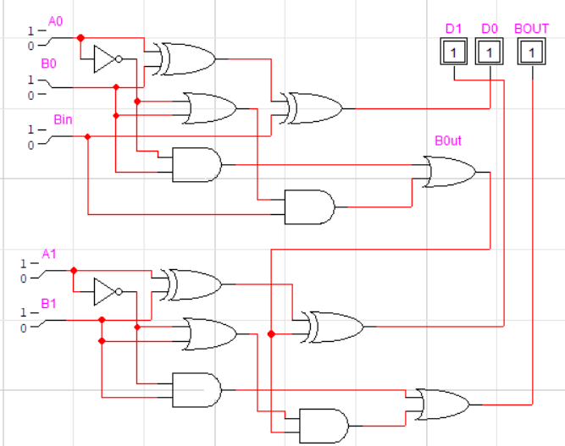

**TASK 4:Create a 2-bit binary multiplier along with its truth table and multiply the number 11 and 11.**

**TRUTH TABLE:**

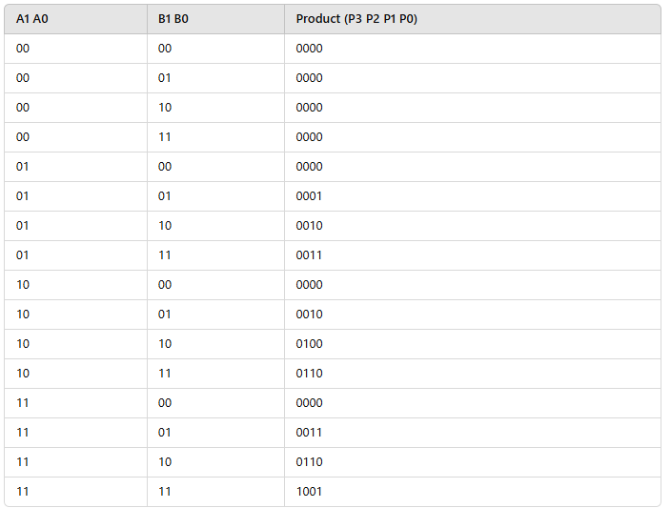

**CIRCUIT:**

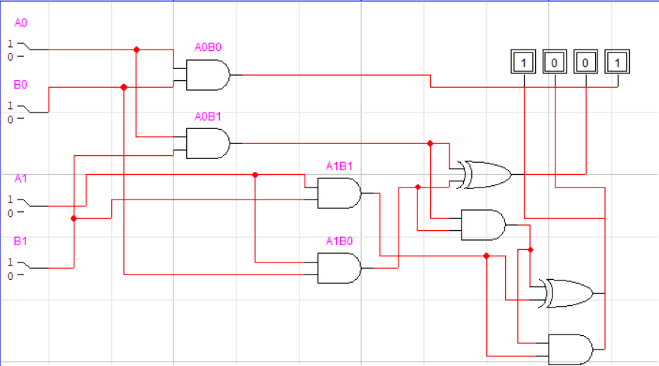

**QUIZ Q1] Design a circuit that turns on an LED(representing a bulb) when a person enters a room and turns it off when they leave. There are two doors (A and B) with sensors(switces).**

**Inputs: A (Entry Sensor), B(Exit Sensor)**

**Output: L (light ON/OFF).**

**TRUTH TABLE:**

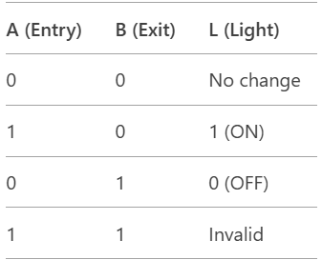

**ON CASE CIRCUIT:**

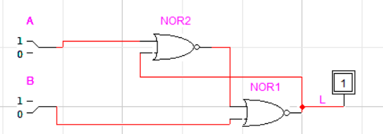

**OFF CASE CIRCUIT:**

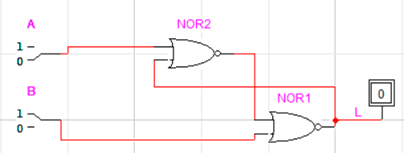

**QUIZ Q2] Design a basic traffic light with three lights (RED , YELLOW , GREEN). Use two switches (S1,S2) to control the signal state:**

**00->RED ON**

**01->YELLOW ON**

**10->GREEN ON**

**11->ALL OFF**

**TRUTH TABLE:**

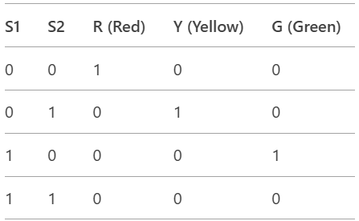

**RED LIGHT:**

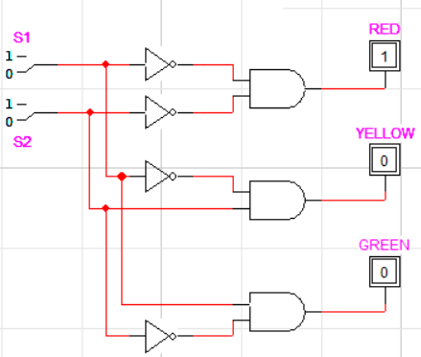

**YELLOW:**

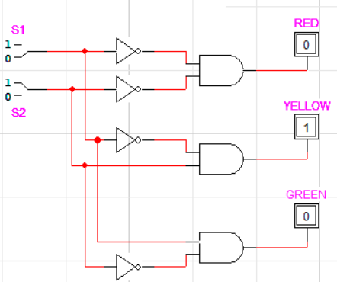

**GREEN:**

